**LAPORAN PRAKTIKUM**

**Pertemuan Ke : 4**

**PEMROGRAMAN PERANGKAT BERGERAK**



NAMA : Dimas Putra Ramadhan

NIM : 4312111019

KELAS : MJ 5A MALAM

DOSEN KOORDINATOR : Ahmadi Irmansyah Lubis, S.Kom., M.Kom.

DOSEN PENGAMPU : Banu Failasuf, S.Tr.

**PROGRAM STUDI TEKNIK MULTIMEDIA DAN JARINGAN**

**JURUSAN TEKNIK INFORMATIKA**

**POLITEKNIK NEGERI BATAM 2023**

**Kegiatan Praktikum Pertemuan Keempat**

1. Membuat form dengan Validasi
2. Membuat InkWell menggunakan Flutter inkWell adalah fitur material widget yang akan menimbulkan efek ripple saat kita klik. Cara kerjanya, hampir sama seperti GestureDetector yaitu bekerja saat user mengklik areanya (Inkwell/Gesture). Namun, hal yang membedakan dari keduanya adalah implementasinya. Inkwell digunakan pada item yang ingin ditap dan menimbulkan kesan efek, seperti item Card, list Card. Sedangkan, GestureDetector digunakan untuk memindahkan/men-drag widget dari posisinya.
3. **Membuat Form dengan GlobalKey**

Source Code :

import 'package:flutter/material.dart';

void main() {

runApp(const MyApp());

}

class MyApp extends StatelessWidget {

const MyApp({super.key});

@override

Widget build(BuildContext context) {

const appTitle = 'Form Validation Demo';

return MaterialApp(

title: appTitle,

home: Scaffold(

appBar: AppBar(

title: const Text(appTitle),

),

),

);

}

}

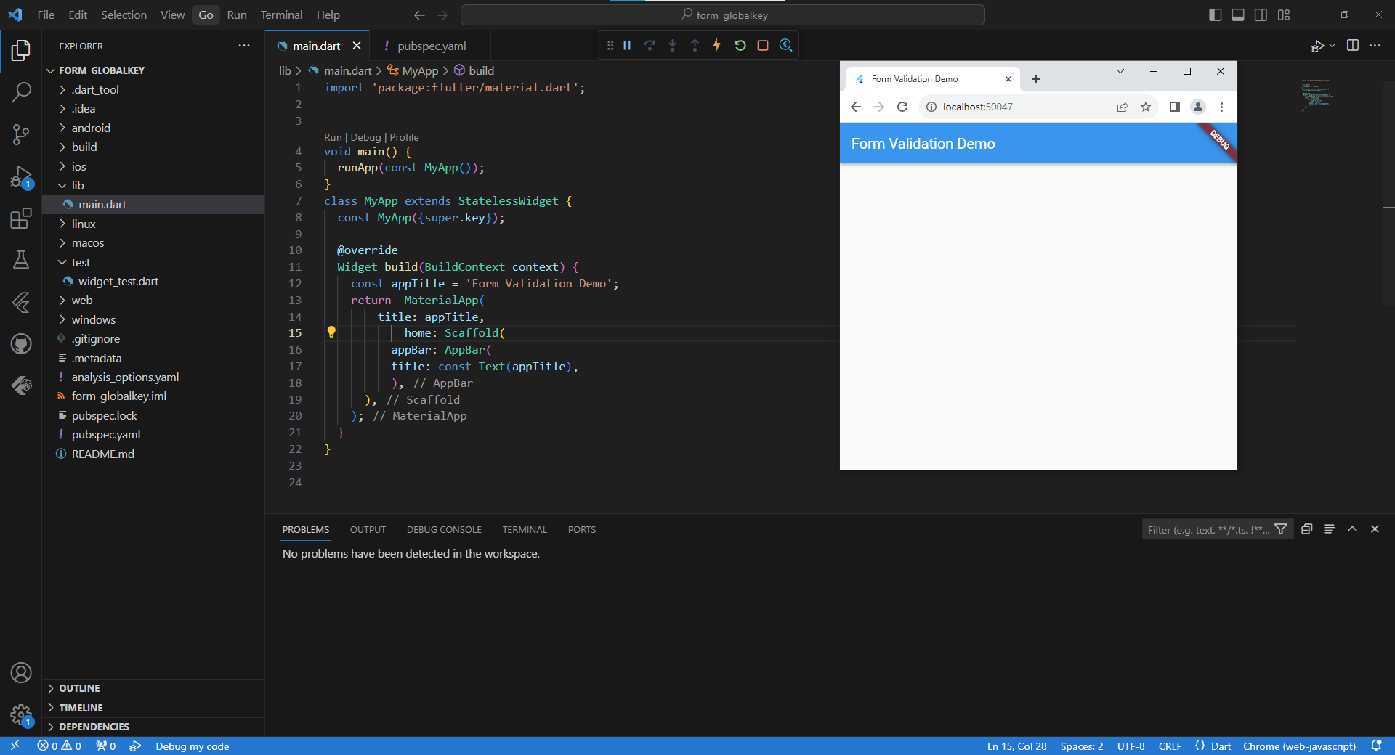Hasilnya:

1. **Menambahkan TextFormField dengan validasi**

Source Code :

import 'package:flutter/material.dart';

void main() {

runApp(const MyApp());

}

class MyApp extends StatelessWidget {

const MyApp({super.key});

@override

Widget build(BuildContext context) {

const appTitle = 'Form Validation Demo';

return MaterialApp(

title: appTitle,

home: Scaffold(

appBar: AppBar(

title: const Text(appTitle),

),

body: const MyCustomForm(),

),

);

}

}

class MyCustomForm extends StatefulWidget {

const MyCustomForm({super.key});

@override

State<MyCustomForm> createState() => _MyCustomFormState();

}

class _MyCustomFormState extends State<MyCustomForm> {

final _formKey = GlobalKey<FormState>();

@override

Widget build(BuildContext context) {

return Form(

key: _formKey,

child: Column(

children: <Widget>[

TextFormField(

validator: (value) {

if (value == null || value.isEmpty) {

return 'Please enter some text';

}

return null;

},

),

],

),

);

}

}

appBar: AppBar(

title: const Text(appTitle),

),

body: const MyCustomForm(),

),

);

}

}

class MyCustomForm extends StatefulWidget {

const MyCustomForm({super.key});

@override

State<MyCustomForm> createState() => _MyCustomFormState();

}

class _MyCustomFormState extends State<MyCustomForm> {

final _formKey = GlobalKey<FormState>();

@override

Widget build(BuildContext context) {

return Form(

key: _formKey,

child: Column(

children: <Widget>[

TextFormField(

validator: (value) {

if (value == null || value.isEmpty) {

return 'Please enter some text';

}

return null;

},

),

],

),

);

}

}

Hasilnya:

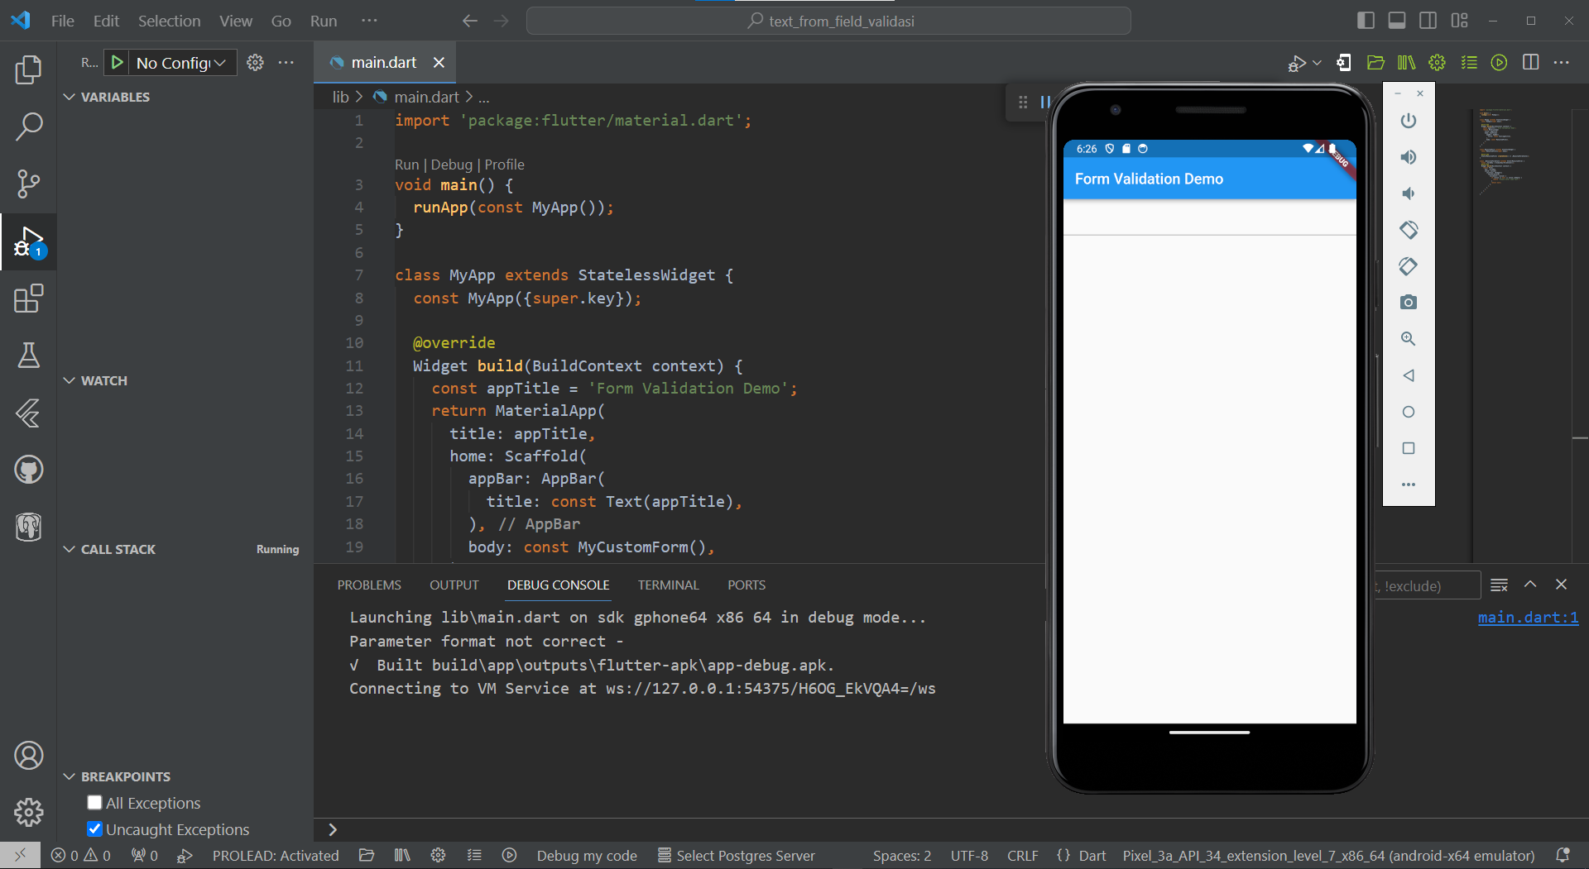

1. **Membuat tombol untuk memvalidasi dan submit form**

Source Code :

import 'package:flutter/material.dart';

void main() => runApp(const MyApp());

class MyApp extends StatelessWidget {

const MyApp({super.key});

@override

Widget build(BuildContext context) {

const appTitle = 'Form Validation Demo';

return MaterialApp(

title: appTitle,

home: Scaffold(

appBar: AppBar(

title: const Text(appTitle),

),

body: const MyCustomForm(),

),

);

}

}

// Create a Form widget.

class MyCustomForm extends StatefulWidget {

const MyCustomForm({super.key});

@override

MyCustomFormState createState() {

return MyCustomFormState();

}

}

class MyCustomFormState extends State<MyCustomForm> {

final _formKey = GlobalKey<FormState>();

@override

Widget build(BuildContext context) {

return Form(

key: _formKey,

child: Column(

crossAxisAlignment: CrossAxisAlignment.start,

children: [

TextFormField(

validator: (value) {

if (value == null || value.isEmpty) {

return 'Please enter some text';

}

return null;

},

),

Padding(

padding: const EdgeInsets.symmetric(vertical: 16.0),

child: ElevatedButton(

onPressed: () {

if (_formKey.currentState!.validate()) {

ScaffoldMessenger.of(context).showSnackBar(

const SnackBar(content: Text('Processing Data')),

);

}

},

child: const Text('Submit'),

),

),

],

),

);

}

}

);

}

}

// Create a Form widget.

class MyCustomForm extends StatefulWidget {

const MyCustomForm({super.key});

@override

MyCustomFormState createState() {

return MyCustomFormState();

}

}

class MyCustomFormState extends State<MyCustomForm> {

final _formKey = GlobalKey<FormState>();

@override

Widget build(BuildContext context) {

return Form(

key: _formKey,

child: Column(

crossAxisAlignment: CrossAxisAlignment.start,

children: [

TextFormField(

validator: (value) {

if (value == null || value.isEmpty) {

return 'Please enter some text';

}

return null;

},

),

Padding(

padding: const EdgeInsets.symmetric(vertical: 16.0),

child: ElevatedButton(

onPressed: () {

if (_formKey.currentState!.validate()) {

ScaffoldMessenger.of(context).showSnackBar(

const SnackBar(content: Text('Processing Data')),

);

}

},

child: const Text('Submit'),

),

),

],

),

);

}

}

child: ElevatedButton(

onPressed: () {

if (_formKey.currentState!.validate()) {

ScaffoldMessenger.of(context).showSnackBar(

const SnackBar(content: Text('Processing Data')),

);

}

},

child: const Text('Submit'),

),

),

],

),

);

}

}

Hasilnya:

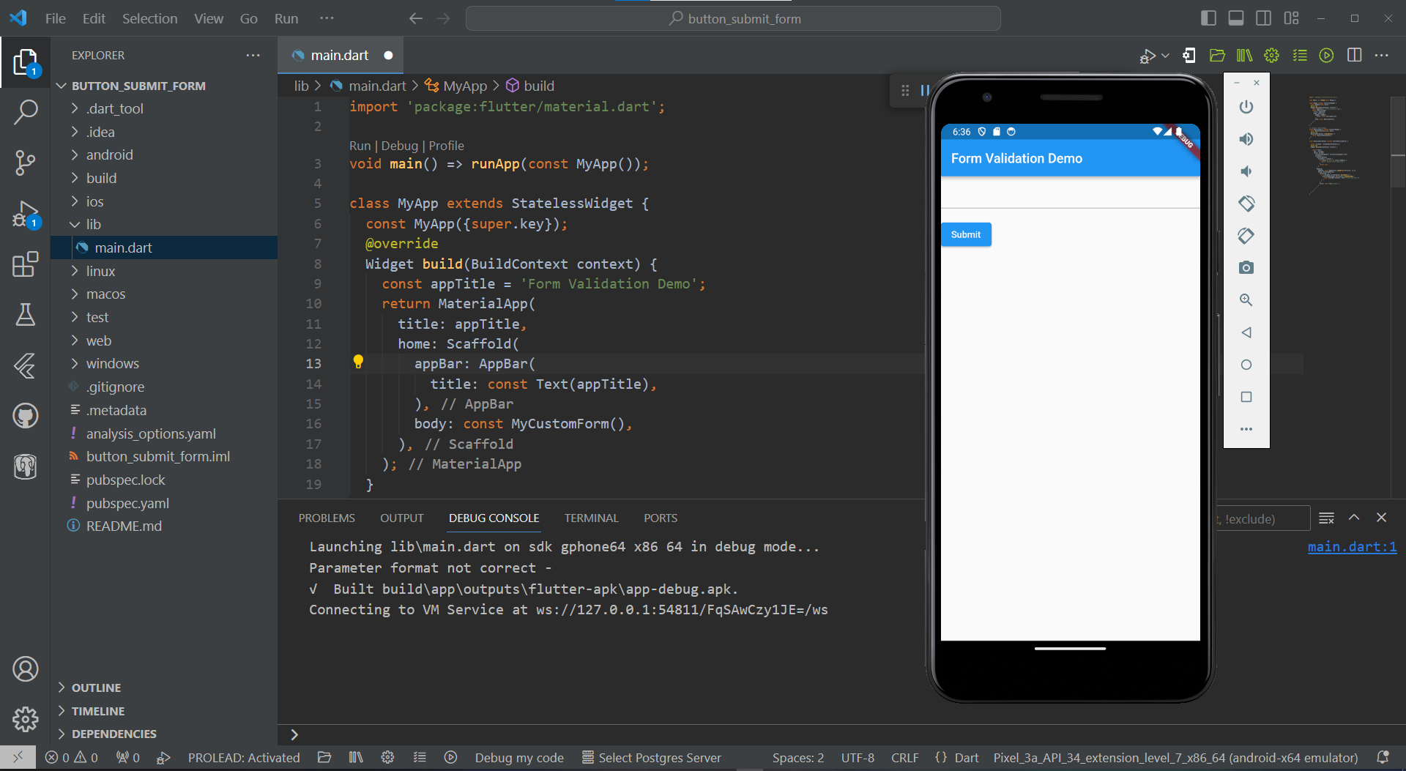

1. **InkWell**

InkWell adalah fitur material widget yang akan menimbulkan efek ripple saat kita klik. Cara kerjanya, hampir sama seperti GestureDetector yaitu bekerja saat user mengklik areanya (Inkwell/Gesture). Namun, hal yang membedakan dari keduanya adalah implementasinya. Inkwell digunakan pada item yang ingin ditap dan menimbulkan kesan efek, seperti item Card, list Card. Sedangkan, GestureDetector digunakan untuk memindahkan/men-drag widget dari posisinya.

Source Code :

import 'package:flutter/material.dart';

void main() {

runApp(MainApp());

}

class MainApp extends StatefulWidget {

@override

_MainAppState createState() => _MainAppState();

}

class _MainAppState extends State<MainApp> {

@override

Widget build(BuildContext context) {

return MaterialApp(

home: Scaffold(

appBar: AppBar(title: Text("InkWell"),),

body: Center(

child: Ink(

decoration: BoxDecoration(

color: Colors.black,

borderRadius: BorderRadius.circular(24),

),

child: InkWell(

borderRadius: new BorderRadius.circular(24),

onTap: () => setState(() {}),

child: Container(

width: 100.0,

height: 100.0,

alignment: Alignment.center,

child: Text(

'InkWell',

style: TextStyle(color: Colors.white, fontSize: 24),

),

),

),

),

),

),

);

}

}

Hasilnya:

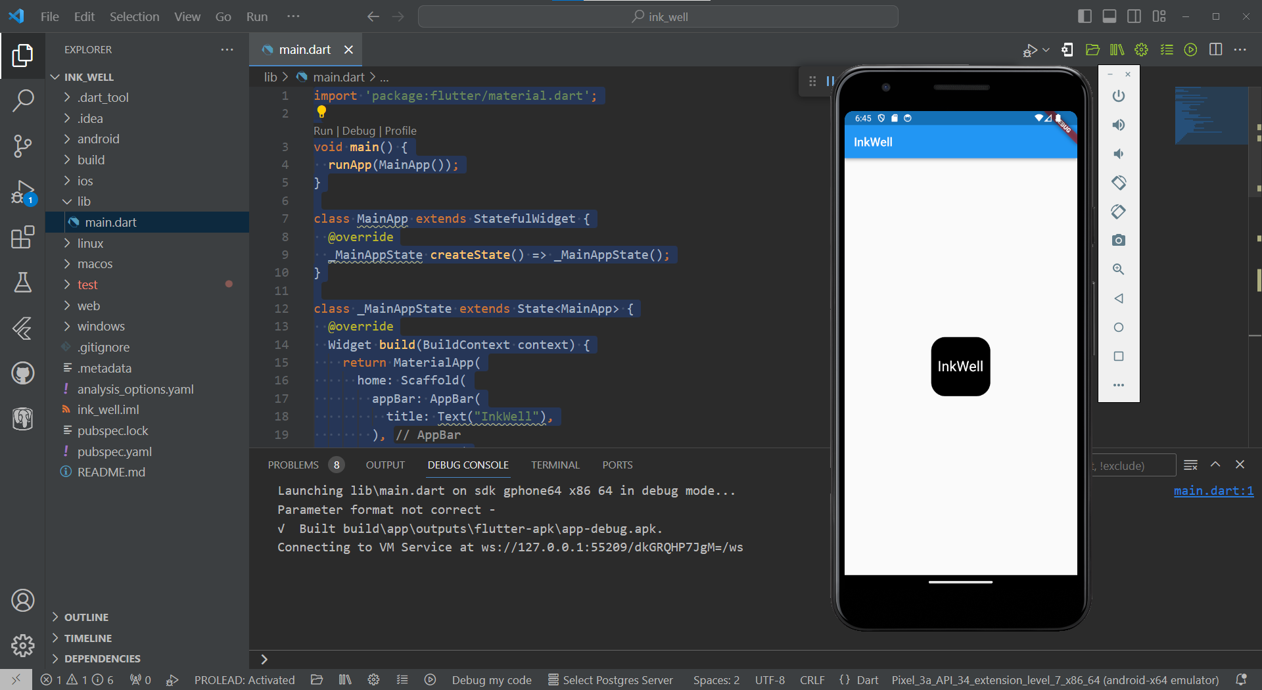

Berikut adalah link github : <https://github.com/AhmadMegistus/4312111019_Dimas-Putra-Ramadhan.git>